

**UNIVERSITY OF PETROLEUM & ENERGY STUDIES**

**Dehradun**

**CONTINOUS INTEGRATION**

**AND**

**CONTINOUS DELIVERY**

**Experiment**

**Name: Rithik Choudhary**

**Course: B. TECH CSE DevOps (2018-22)**

**Roll no.: R171218084**

**Sapid: 500069261**

**Experiment-5**

**Jenkins integration with SonarQube**

**Step-1: Start and login to Jenkins**

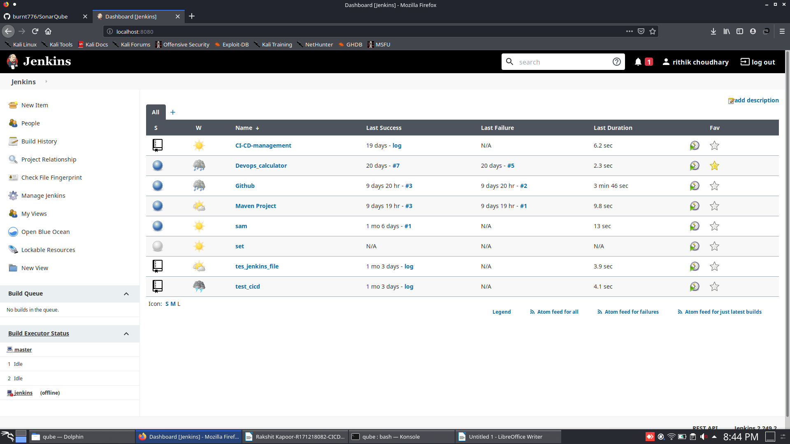

**Step-2: Click on the new item and select maven project and provide the name to it and click on ok.**

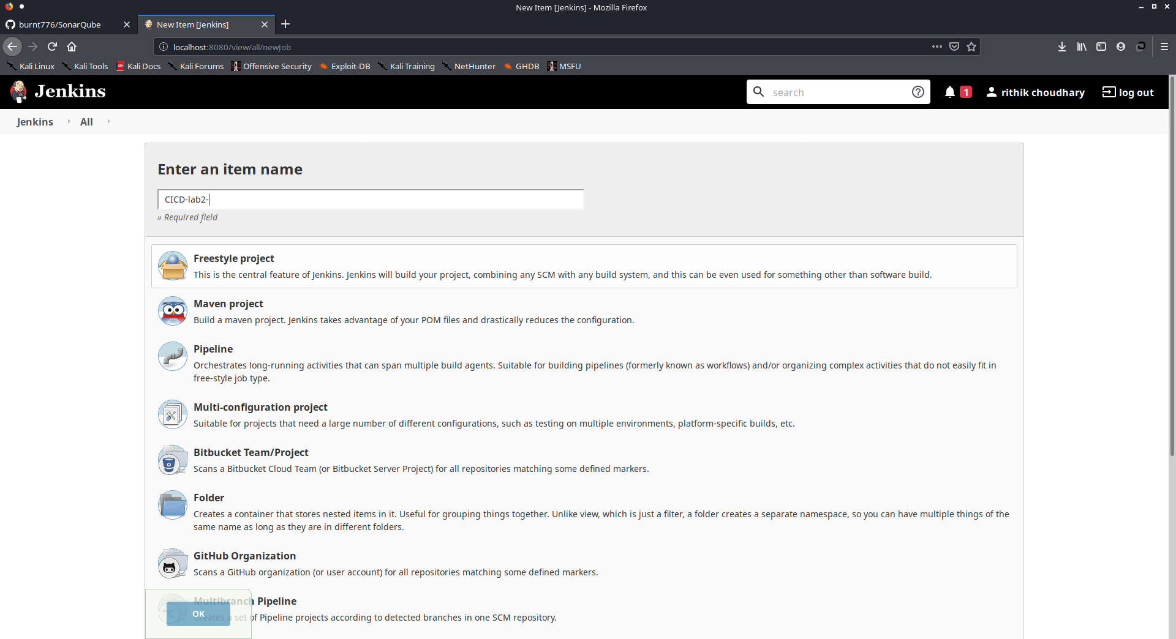

**Step-3: provide the URL of the repository and path of pom.xml file and mention the goals. Click on Save.**

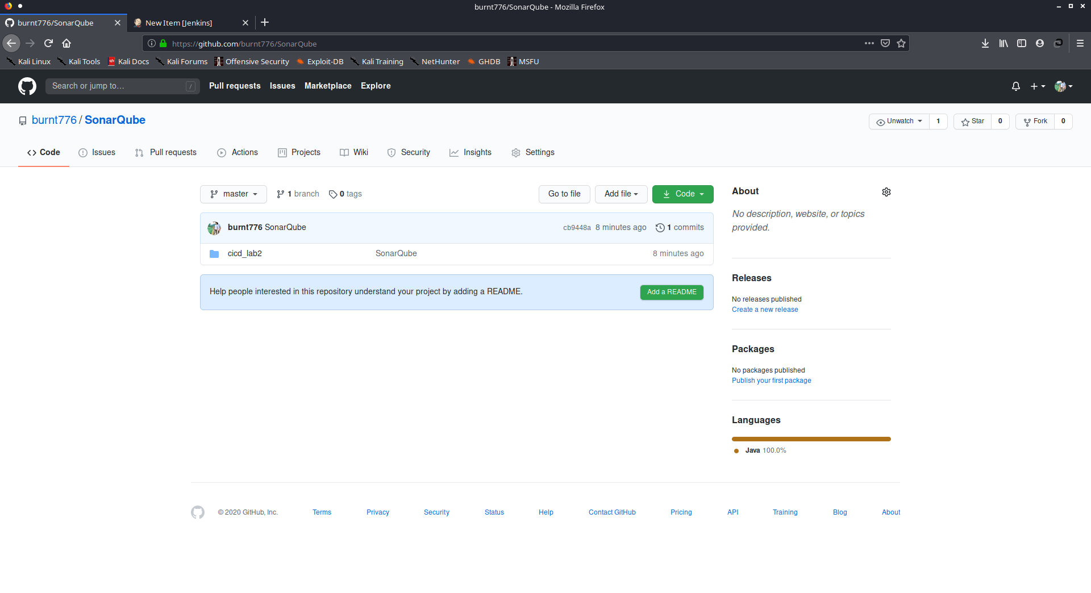

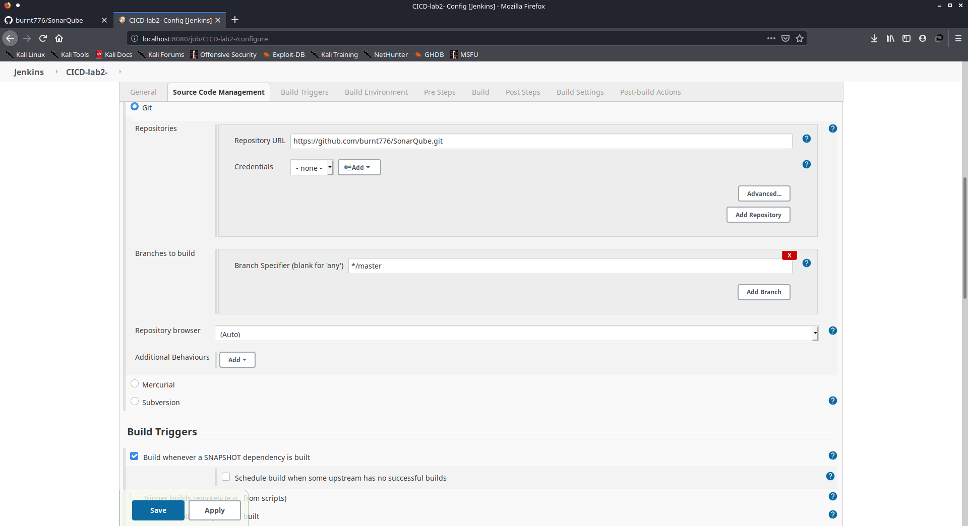

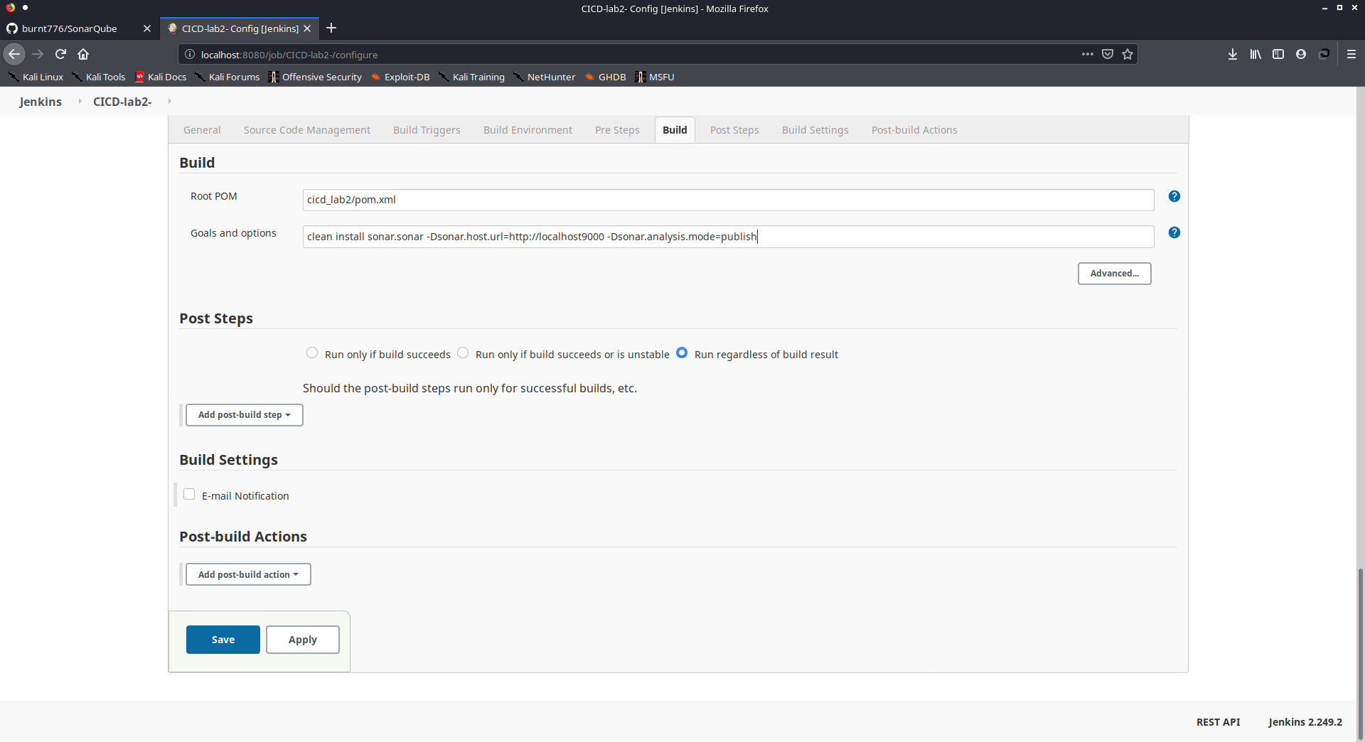

**Step-4: Install the plugins for the SonarQube and make changes to Configuration System and provide the path.**

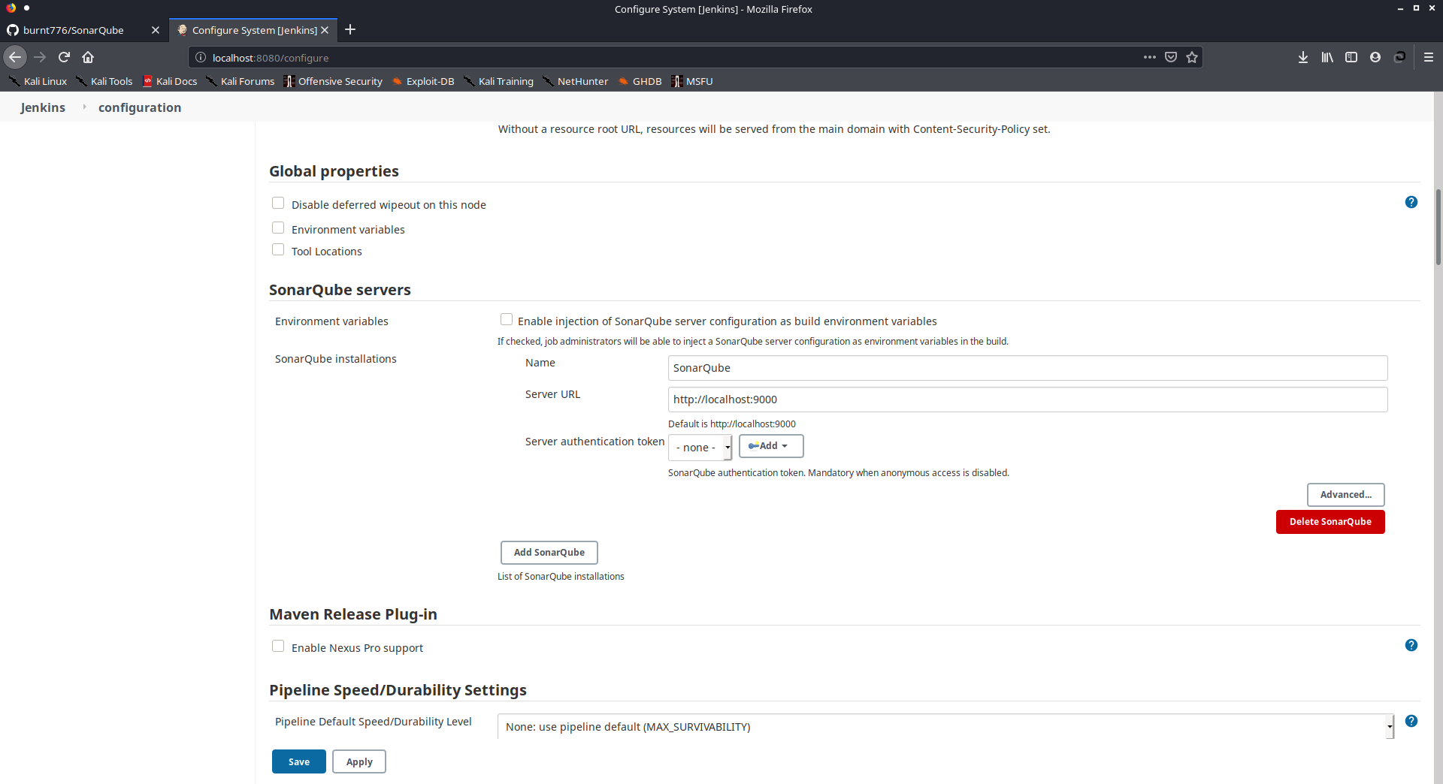

**Step-5: Click on build now to and see the changes on SonarQube.**

